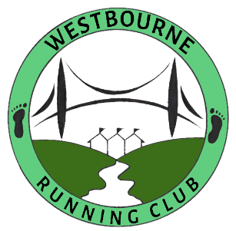
Codes of Conduct
Of Westbourne RC Officials

1 Responsibilities – Professional Standards
1.1 Officials (the Committee and club volunteers) play a vital role in the preparation and delivery of safe and high-quality athletics events. The code of conduct for officials reflects the required standards of personal and professional conduct in that role.
1.2 To maximise the benefits and minimise the risks to participants, officials must attain an appropriate level of competence through qualifications, and a commitment to ongoing training to ensure safe and correct practice.
2 Officials will
2.1 Abide by the UKA and the HCAF Adult Safeguarding Policy and Procedures
2.2 Keep professional knowledge and skills up to date, be appropriately qualified and renew licences as and when required by UKA.
2.3 Work in a spirit of co-operation with other officials and not interfere with their responsibilities.
2.4 Offer guidance and support to less experienced officials whenever appropriate.
2.5 Report any accidental injury, distress, misunderstanding or misinterpretation to the parents/ carers and club/regional/national or UKA Safeguarding Officer as soon as possible.
2.6 Challenge and report any inappropriate behaviour or suspected misconduct by other technical officials, coaches or other people involved in athletics to a club (where relevant), HCAF or UKA as soon as possible.
2.7 Act without discrimination on grounds of age, gender, sexual, cultural, ethnic, disability or religious preference.
2.8 Be dignified and display courtesy and good manners towards others; not undermine, put down or belittle other officials, athletes, coaches or practitioners.
2.9 Ensure the welfare and safety of members and officials.
2.10 Promote positive aspects of the sport such as fair play and never condone rule violations or the use of prohibited or age-inappropriate substances.
2.11 Avoid destructive behaviour; swearing and critical, abusive language or irresponsible behaviour, including behaviour that is dangerous to others including acts of violence, bullying, harassment and physical and sexual abuse.
3 Responsibilities – Personal Standards
3.1 Officials must demonstrate proper personal behaviour and conduct at all times; to respect the rights of every individual to participate safely; develop positive relationships with participants (and others) based on openness, honesty, mutual trust and respect.
4 Breaches of the code of conduct
4.1 Depending upon the severity of the breach the club will follow the procedures as set out in the club grievance and disciplinary policy.
It may result in:
4.1 A verbal warning or written warning
4.2 Compulsory attendance of supplementary safeguarding training
4.3 Suspension by the club/HCAF/UKA
4.4 Dismissal from the club/HCAF/UKA
4.5 UKA technical official’s licence withdrawn
4.6 Be referred to DBS

Last updated 10 February 2023

